VIVA - 2

1. **AIM :** Create any Mountain Range with Snowfall over it using GIMP –

**Follow the below steps –**

* Add an image of mountains to GIMP.
* Set foreground color to black.
* Add a new layer and set its color as foreground color.
* Go to filters -> noise -> HSV noise.
* Set dulling and value to full.
* Go to filters -> blur -> Gaussian blur.
* Set size X and Y to 1.0.
* Go to colors -> levels.
* Bring right most arrow to left. Adjust the positioning of the arrows till they give a snow effect.
* 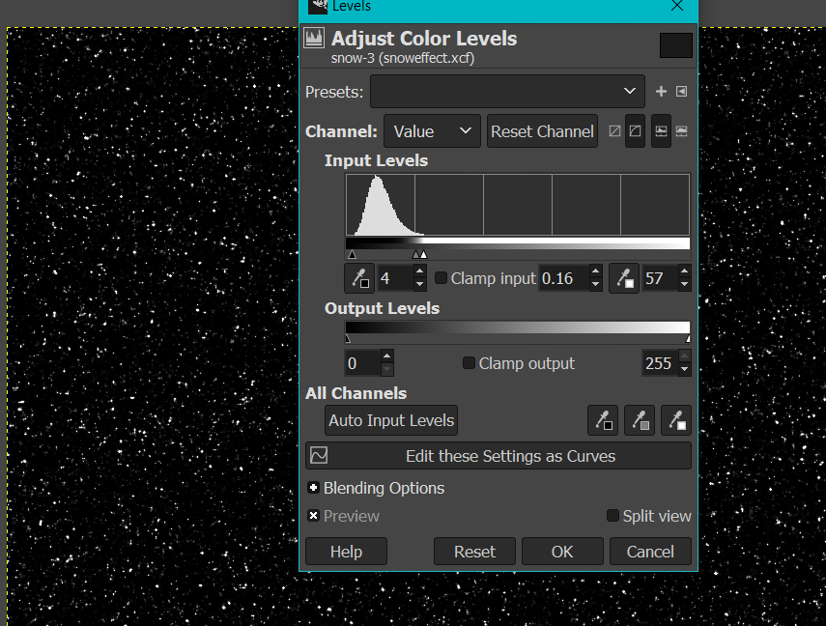
* Go to Mode -> screen.
* You will get the snow effect over your image.

OUTPUT -

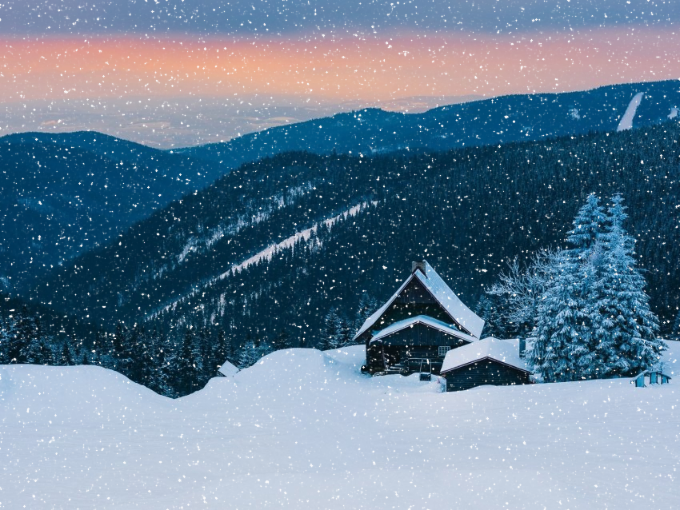

1. Create any City or Skyscraper using Blender.

**Follow the following steps –**

1. Open Blender workspace delete the existing cube and Click on the add option and add a sphere.

2. Then we will make some adjustments in the sphere like length and breadth.

3. Subdivide the sphere and go to the edit mode to make changes.

3. After making changes in the sphere we will select the upper part of sphere and then extrude it. Like this we are going to increase the length of our building.

4. After this add edge loops to make windows of the building.

6. Extrude outwards to make windows and give them proper shape.

5. Now add new material on the windows and set roughness to 0 and transmission to1.

6. Now go to shading part and add various properties like noise texture, bump etc to give realistic effects on windows.

7. Extrude the upper part of the building outwards to make shape of upper part accordingly.

**OUTPUT –**

